***Analysis 3-hour plots (1_Drive)***

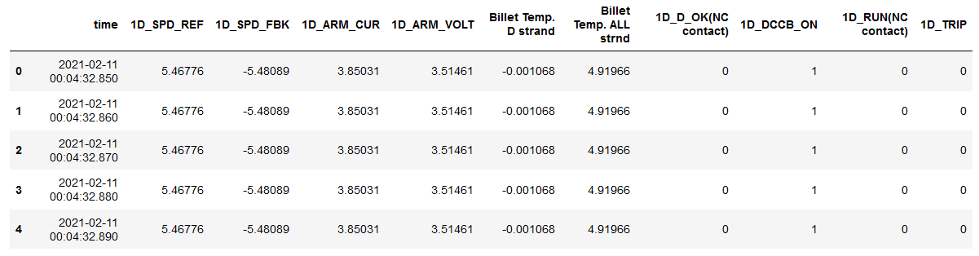Rows-85,80,000 Columns-10

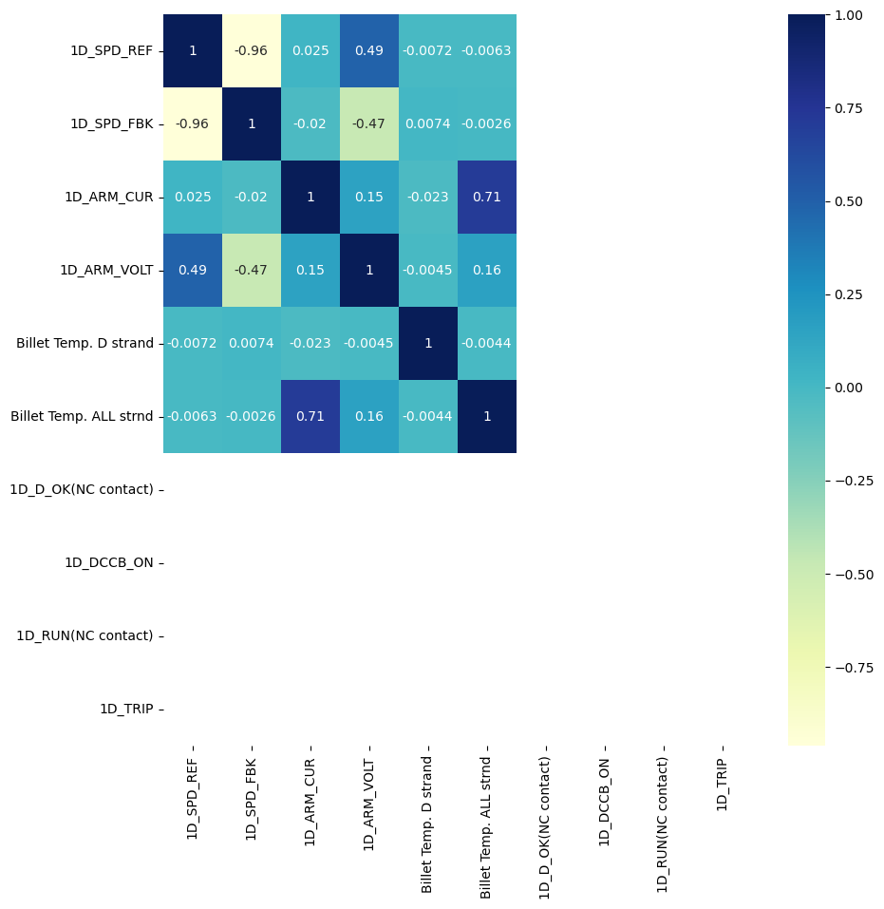

**Visualization of Categorical Features:**

4 categorical variables - 1D_D_OK(NC contact) , 1D_DCCB_ON , 1D_RUN(NC contact) , 1D_TRIP

Plotting count plots of each categorical variable to check the label:

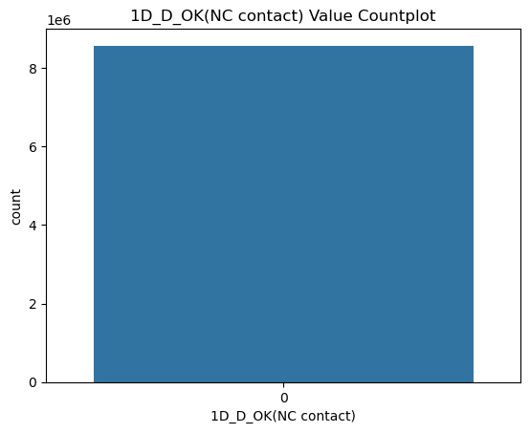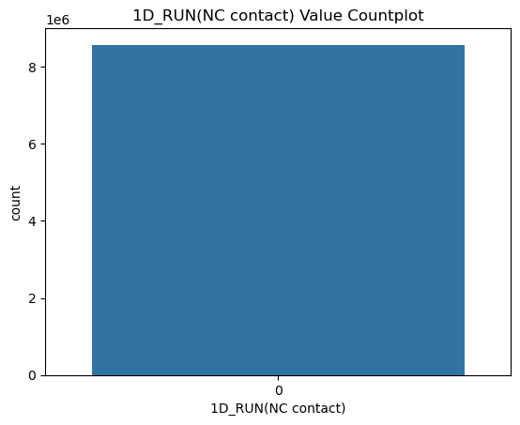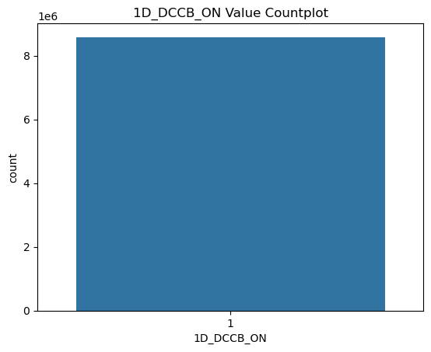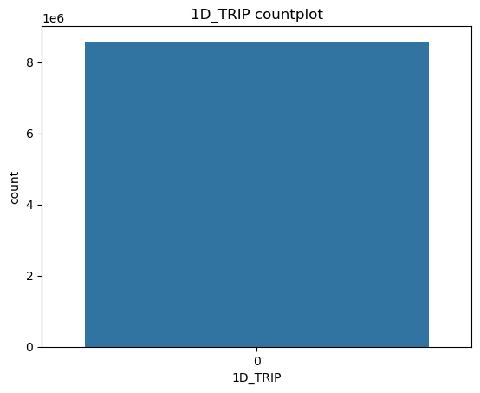

Analysis:

* 1D_D_OK(NC contact): Drive is fit for running all-day
* 1D_DCCB_ON: *Direct Current Circuit Breaker is ON* for all-day
* 1D_RUN(NC contact): Drive is running for all day
* 1D_TRIP: *Trip mechanism of the drive 1 is working* for all-day

**Visualization of Numerical Variables**:

Numerical Variables: 1D_SPD_REF, 1D_SPD_FBK, 1D_ARM_CUR, 1D_ARM_VOLT, Billet Temp. 'D' strand, Billet Temp. ALL strnd

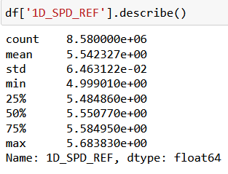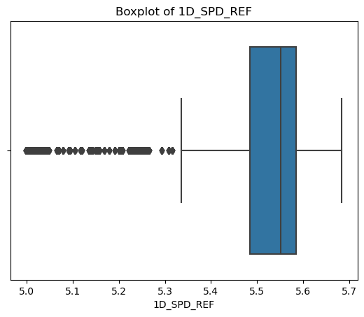

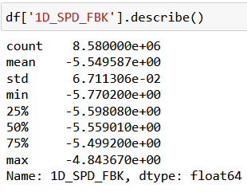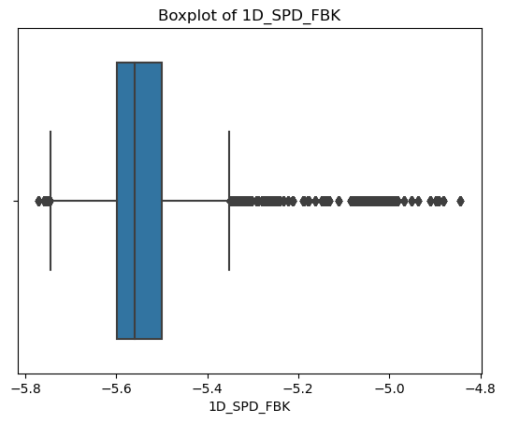

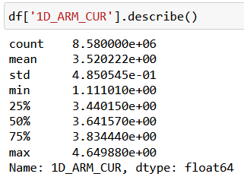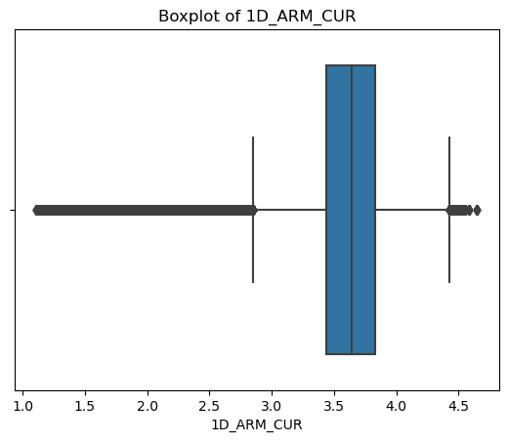

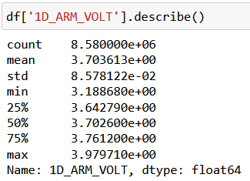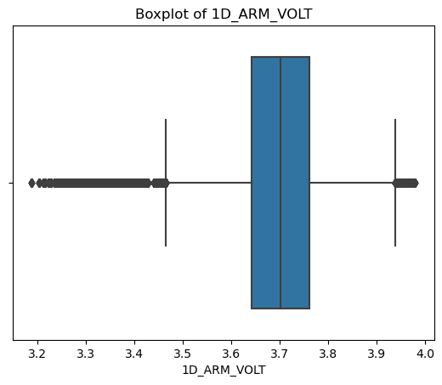

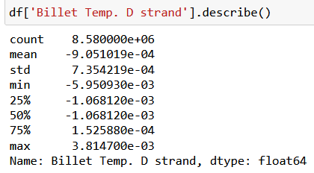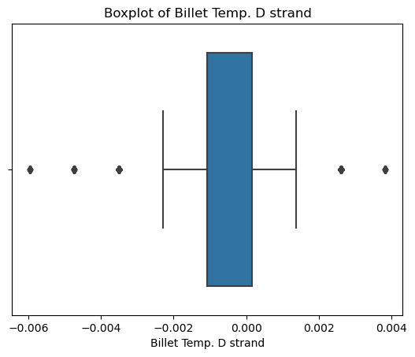

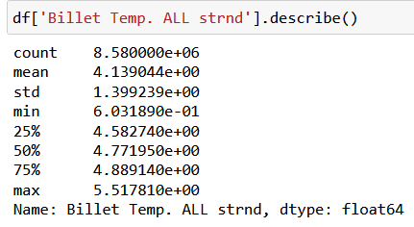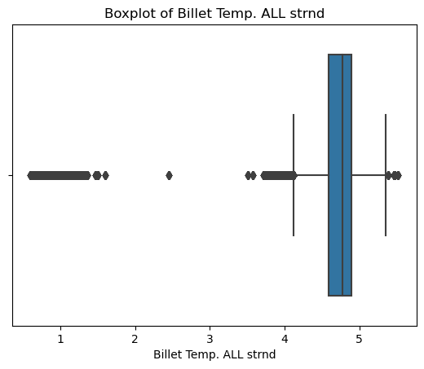

***Time Series Plots of Numerical Variables***

***Part 1: 0-3 hours***

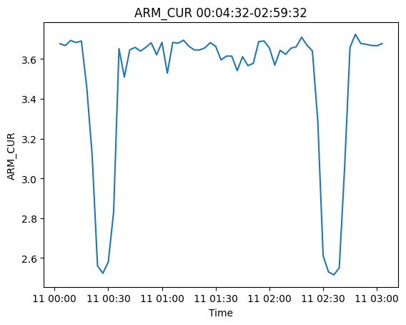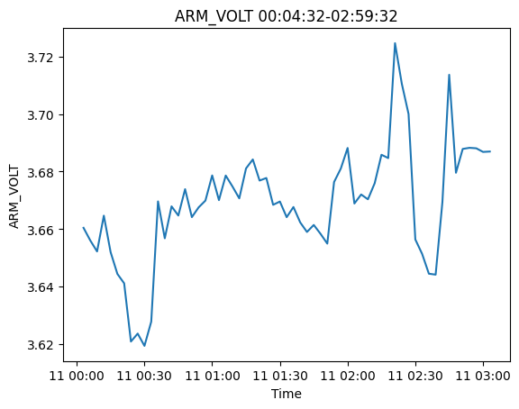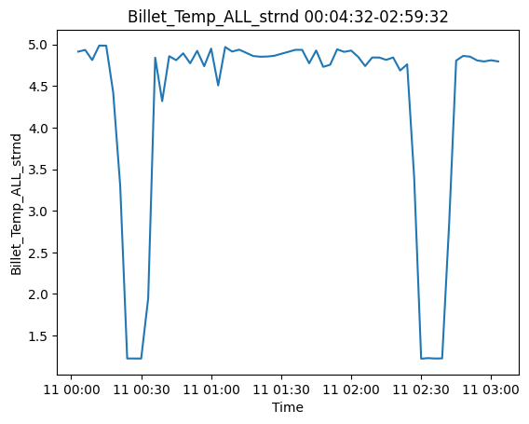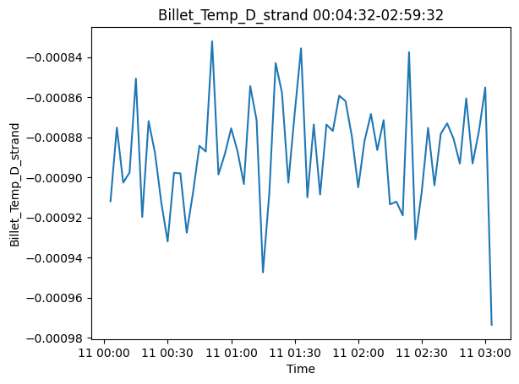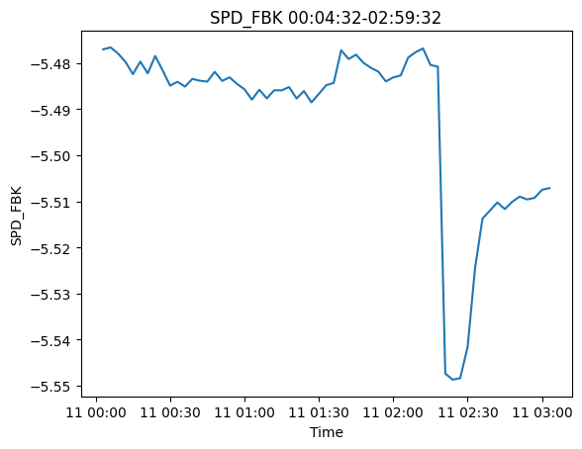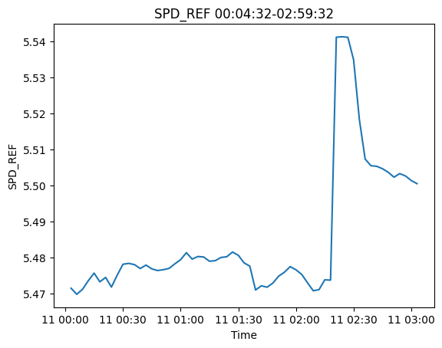

***Part 2: 3-6 hours***

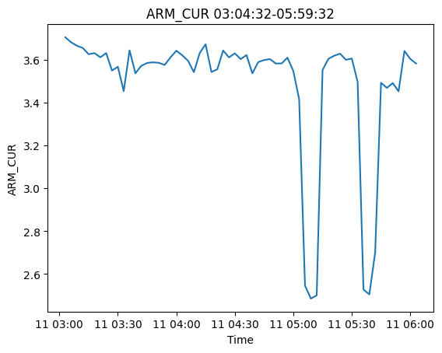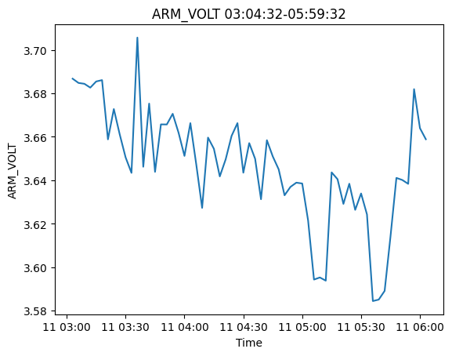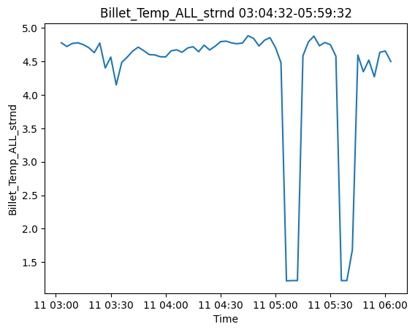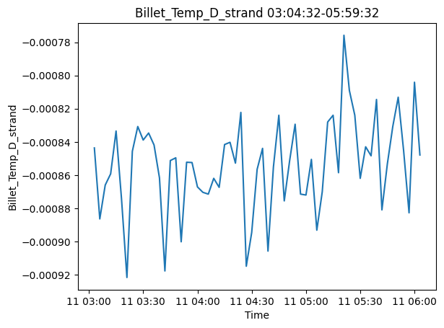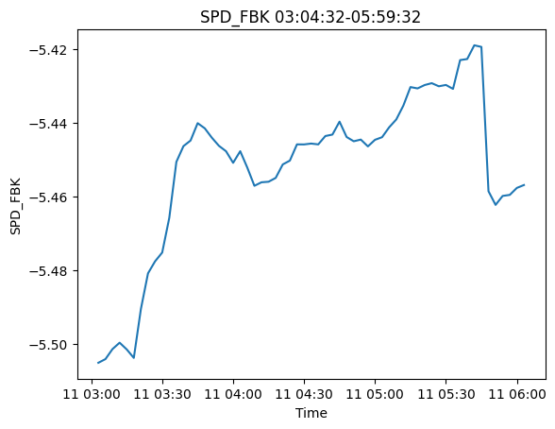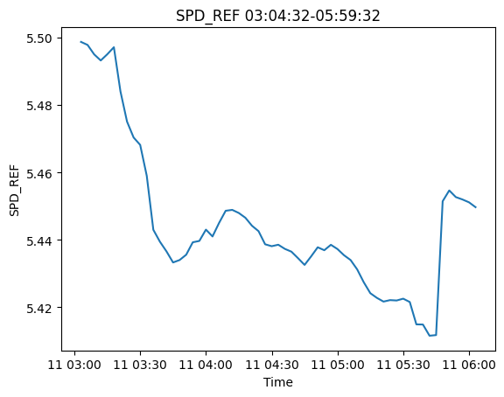

***Part 3: 6-9 hours***

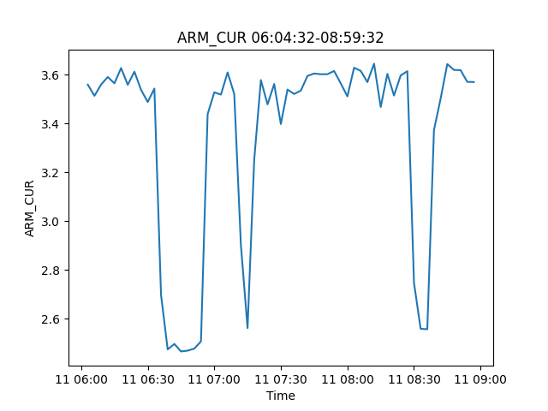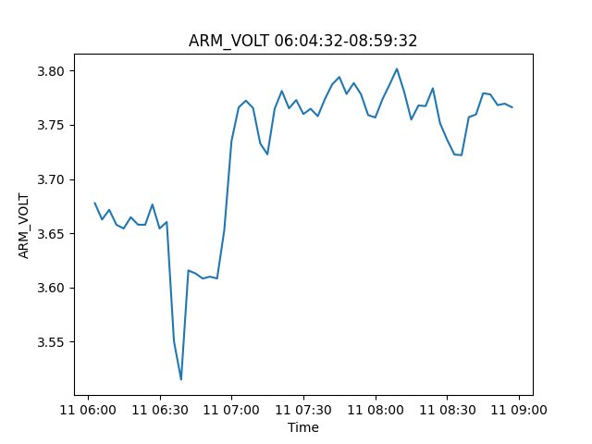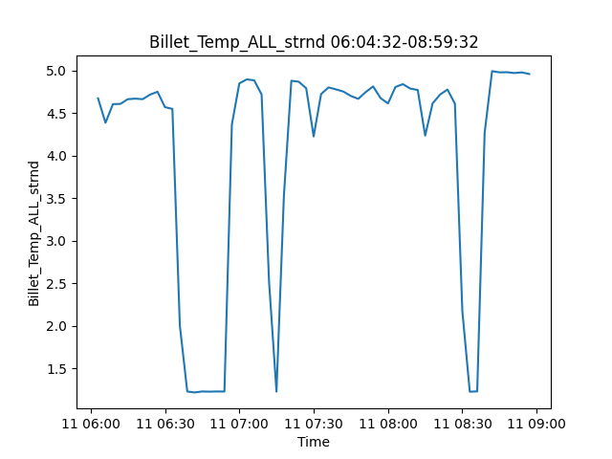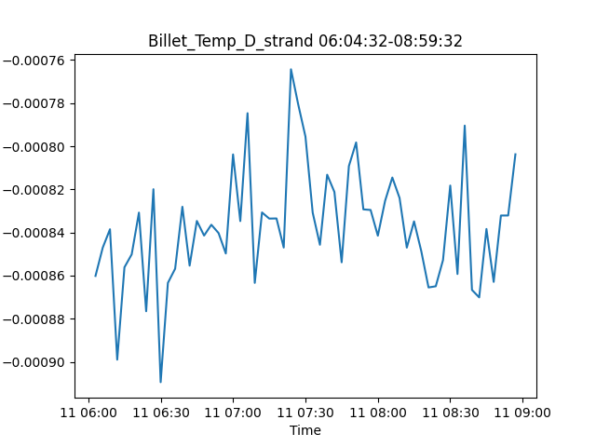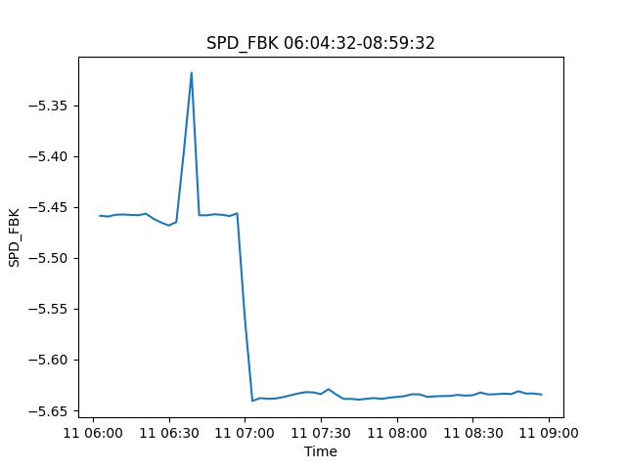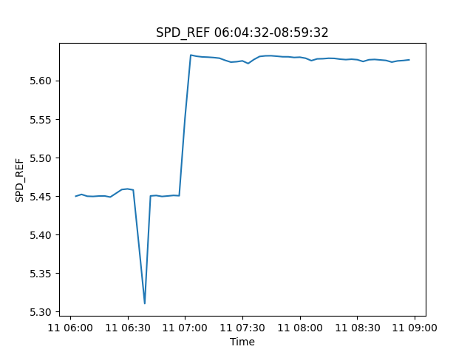

***Part 4: 9-12 hours***

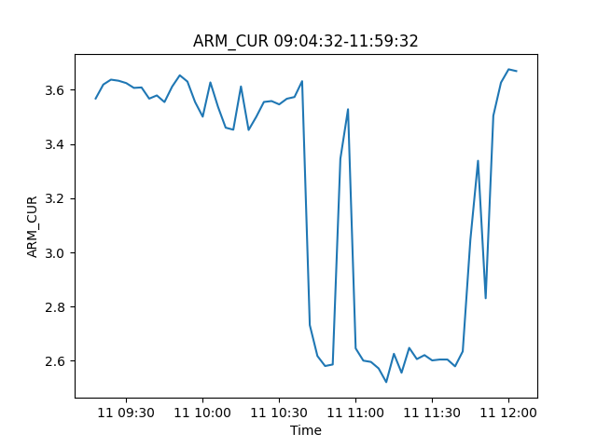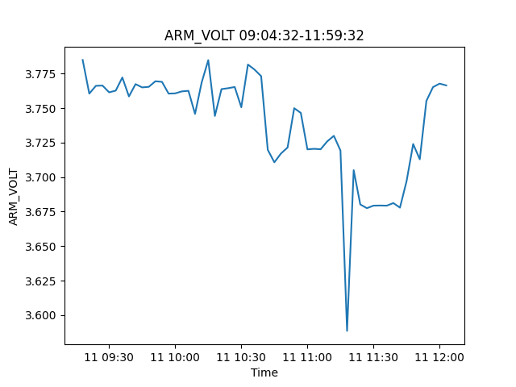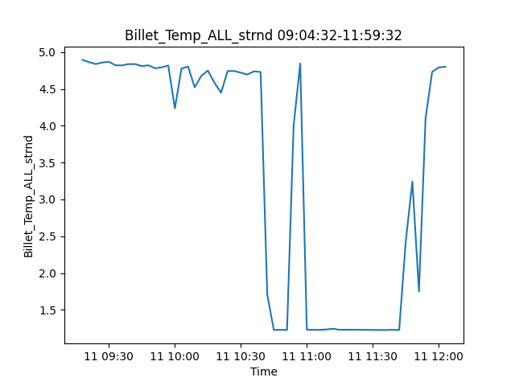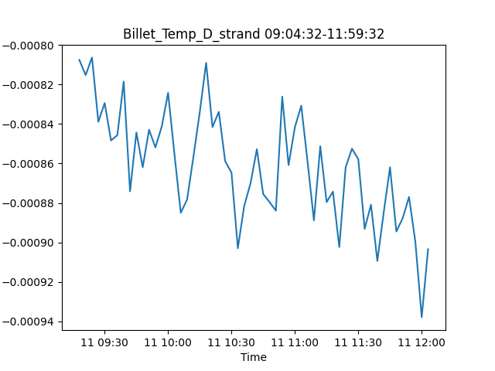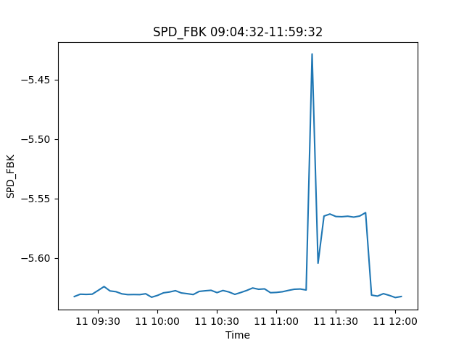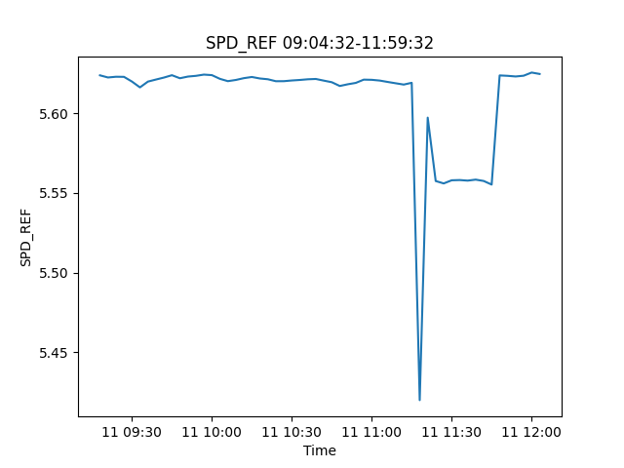

***Part 5: 12-15 hours***

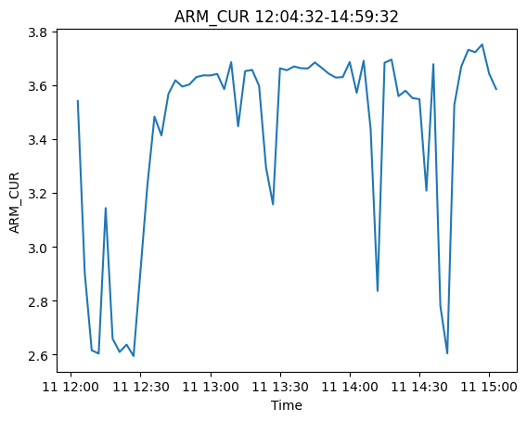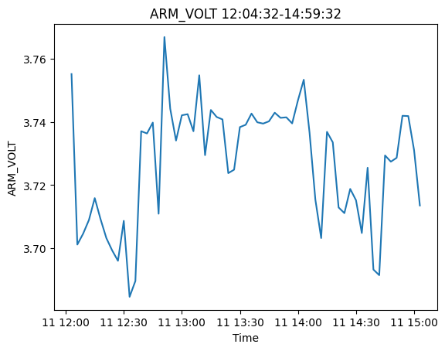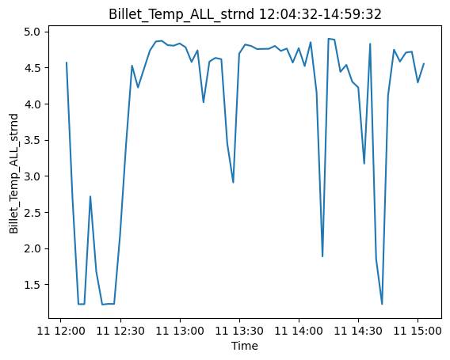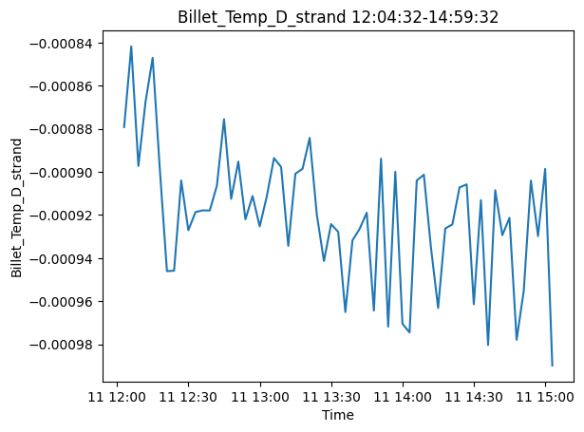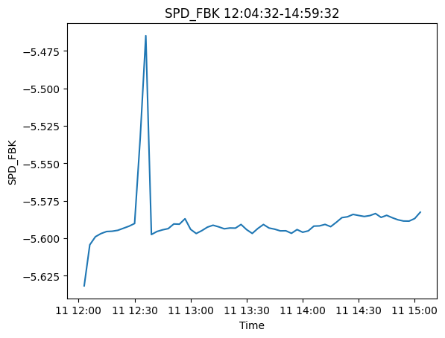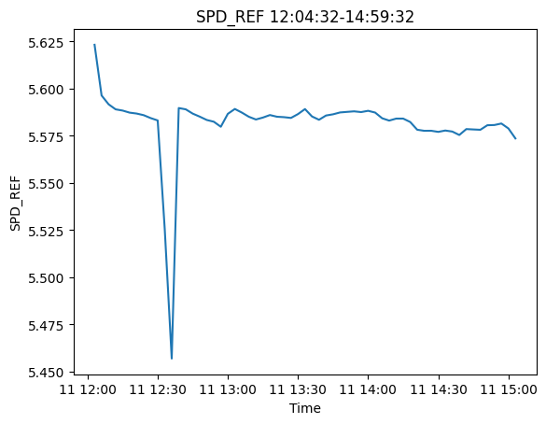

***Part 6: 15-18 hours***

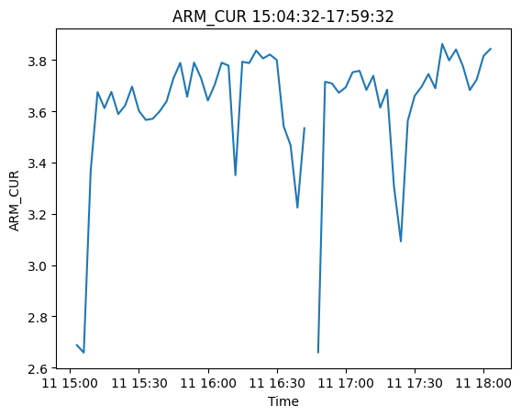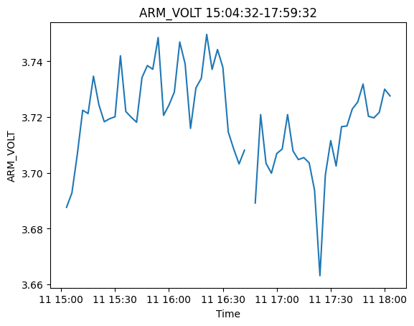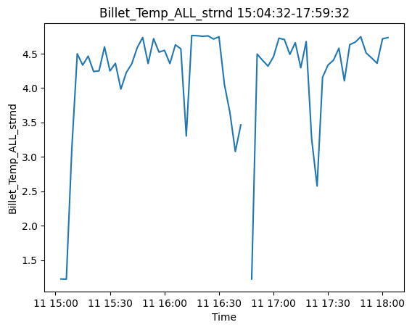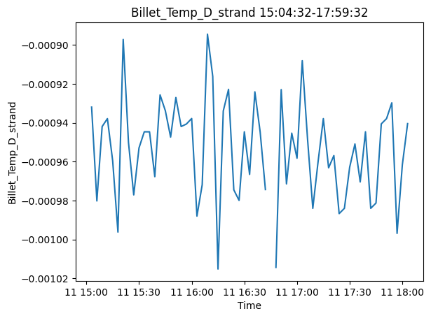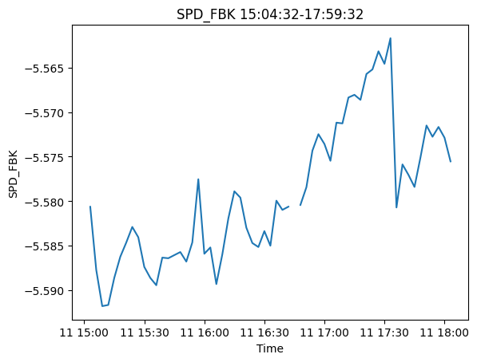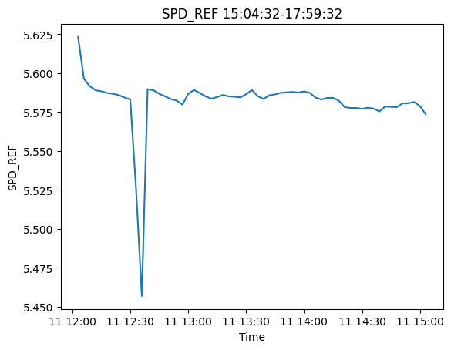

***Part 7: 18-21 hours***

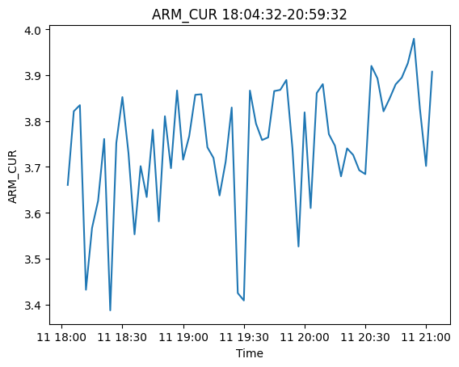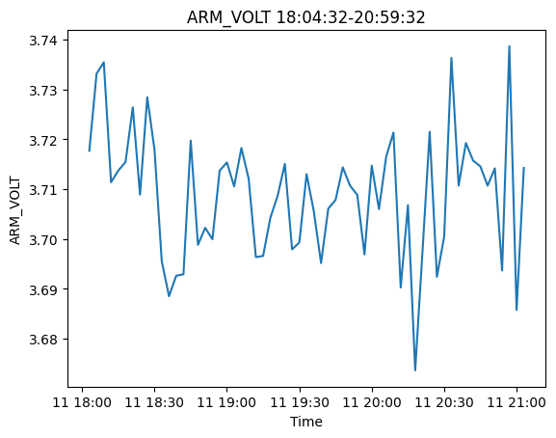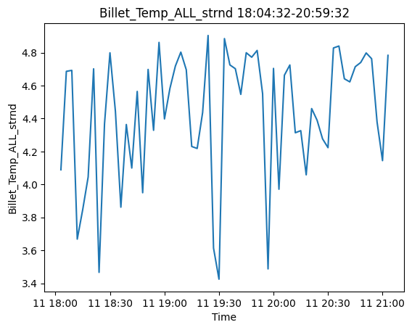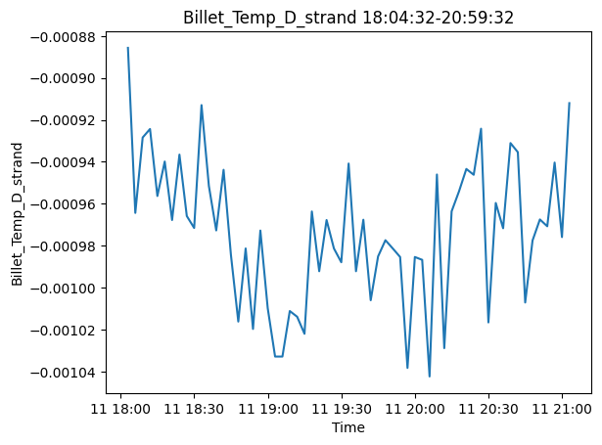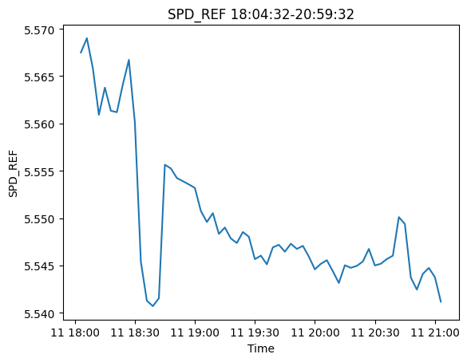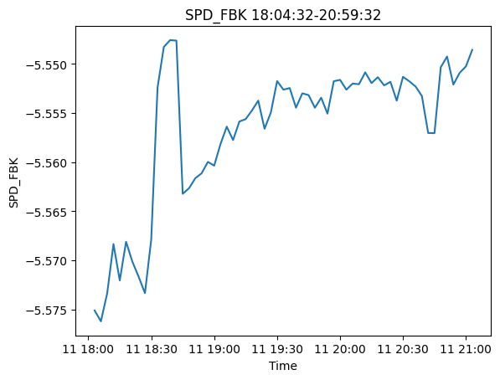

***Part 8: 21-24 hours***

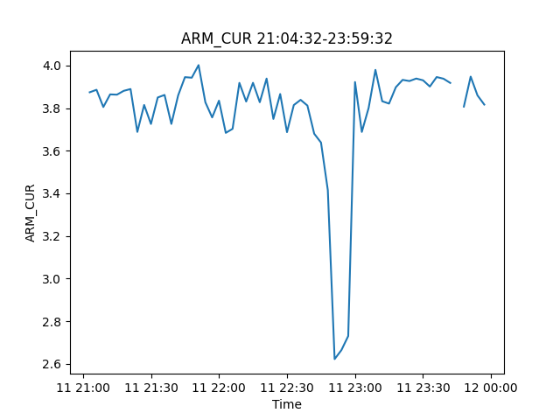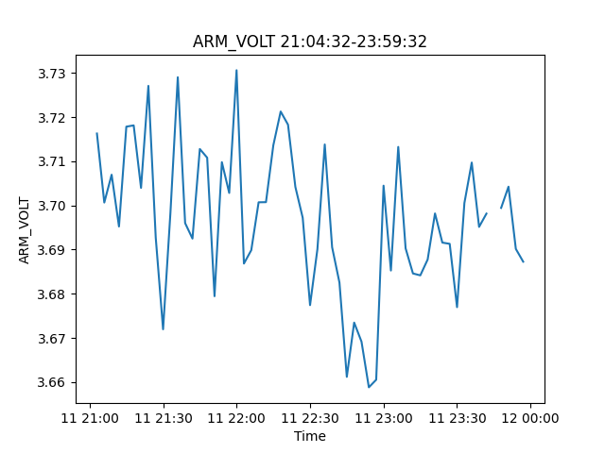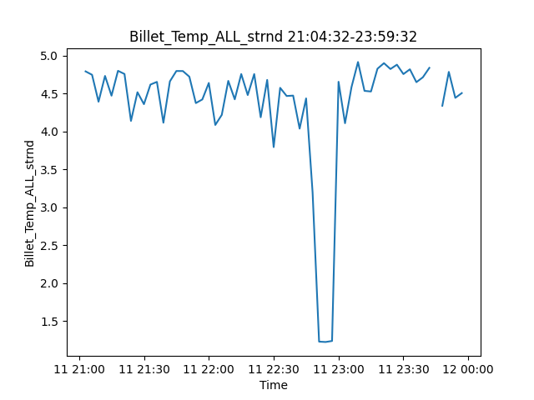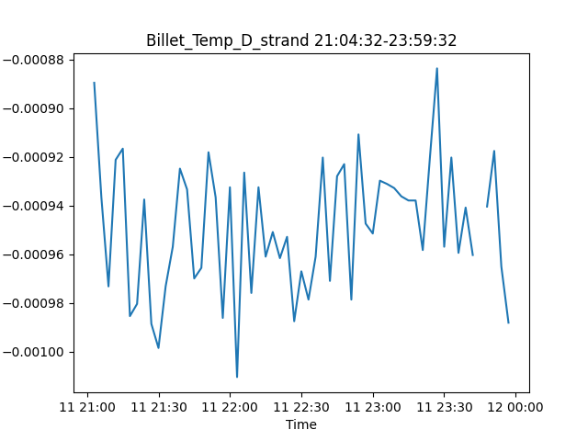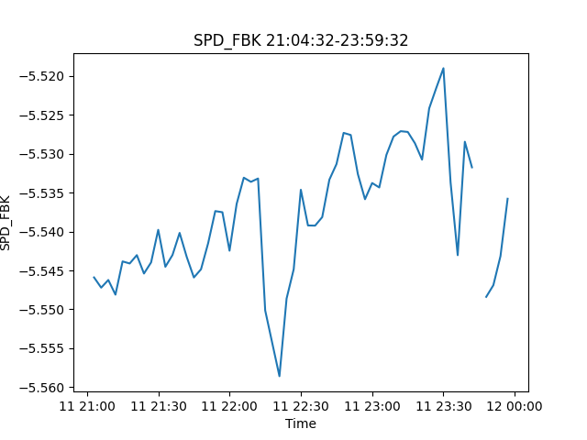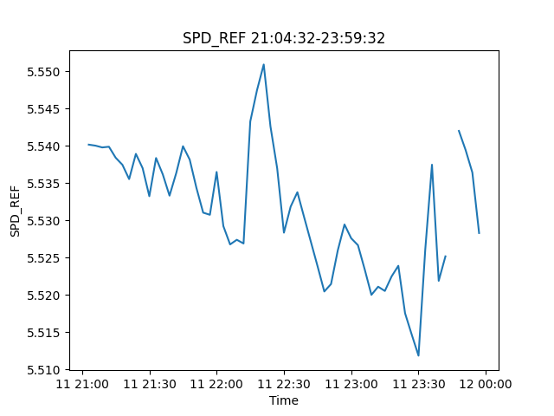

**Anomalies**

Anomalies were detected using Isolation Forest Algorithm and were saved along with their timestamps as a csv file. The below mentioned anomalies are in intervals of 5 minutes within each other.

Total Anomalies detected: 73

Their timestamps:

2021-02-11 00:10:49.860000 - 2021-02-11 00:10:55.250000  
2021-02-11 00:18:27.660000 - 2021-02-11 00:41:45.670000  
2021-02-11 00:57:53.690000 - 2021-02-11 00:57:55.880000  
2021-02-11 01:04:23.500000 - 2021-02-11 01:04:27.690000  
2021-02-11 01:43:04.930000 - 2021-02-11 01:43:05.120000  
2021-02-11 01:50:47.740000 - 2021-02-11 01:52:32.330000  
2021-02-11 02:05:59.550000 - 2021-02-11 02:05:59.740000  
2021-02-11 02:23:28.360000 - 2021-02-11 02:23:28.550000  
2021-02-11 02:35:00.770000 - 2021-02-11 02:46:00.570000  
2021-02-11 03:29:13.410000 - 2021-02-11 03:40:57.610000  
2021-02-11 04:39:26.060000 - 2021-02-11 04:39:27.850000  
2021-02-11 04:52:31.270000 - 2021-02-11 04:54:36.470000  
2021-02-11 05:00:12.480000 - 2021-02-11 05:26:34.490000  
2021-02-11 05:32:00.510000 - 2021-02-11 05:56:25.120000  
2021-02-11 06:02:24.530000 - 2021-02-11 06:08:10.720000  
2021-02-11 06:32:54.550000 - 2021-02-11 06:57:25.560000  
2021-02-11 07:11:21.590000 - 2021-02-11 07:11:21.980000  
2021-02-11 07:16:31.990000 - 2021-02-11 07:16:32.180000  
2021-02-11 07:40:53.410000 - 2021-02-11 07:45:57.400000  
2021-02-11 07:58:58.220000 - 2021-02-11 07:58:58.410000  
2021-02-11 08:00:43.020000 - 2021-02-11 08:00:43.810000  
2021-02-11 08:18:40.040000 - 2021-02-11 08:58:38.260000  
2021-02-11 09:19:48.690000 - 2021-02-11 09:31:33.490000  
2021-02-11 09:36:55.900000 - 2021-02-11 09:37:38.090000  
2021-02-11 09:48:57.510000 - 2021-02-11 09:52:10.900000  
2021-02-11 09:59:59.920000 - 2021-02-11 09:59:59.990000  
2021-02-11 10:00:00 - 2021-02-11 10:00:00.110000  
2021-02-11 10:20:43.540000 - 2021-02-11 10:20:43.730000  
2021-02-11 11:09:35.970000 - 2021-02-11 11:09:36.160000  
2021-02-11 11:19:58.780000 - 2021-02-11 11:22:13.170000  
2021-02-11 11:46:46 - 2021-02-11 11:46:54.990000  
2021-02-11 12:05:13.020000 - 2021-02-11 12:14:08.410000  
2021-02-11 12:19:18.030000 - 2021-02-11 12:19:18.820000  
2021-02-11 12:27:19.230000 - 2021-02-11 12:27:19.420000  
2021-02-11 12:34:15.440000 - 2021-02-11 12:39:46.640000  
2021-02-11 13:24:01.480000 - 2021-02-11 13:24:01.670000  
2021-02-11 13:57:08.110000 - 2021-02-11 13:57:08.300000  
2021-02-11 14:32:52.330000 - 2021-02-11 14:32:52.520000  
2021-02-11 14:50:50.150000 - 2021-02-11 14:50:50.340000  
2021-02-11 15:02:48.160000 - 2021-02-11 15:32:11.970000  
2021-02-11 15:38:06.190000 - 2021-02-11 15:45:34.580000  
2021-02-11 15:52:46 - 2021-02-11 15:52:46.190000  
2021-02-11 17:02:41.050000 - 2021-02-11 17:02:41.240000  
2021-02-11 17:21:06.270000 - 2021-02-11 17:21:06.460000  
2021-02-11 17:33:43.280000 - 2021-02-11 17:41:11.870000  
2021-02-11 17:47:53.290000 - 2021-02-11 17:47:55.480000  
2021-02-11 17:53:35.490000 - 2021-02-11 17:55:34.690000  
2021-02-11 18:05:20.500000 - 2021-02-11 18:05:26.490000  
2021-02-11 18:12:41.510000 - 2021-02-11 18:18:41.900000  
2021-02-11 18:27:09.520000 - 2021-02-11 18:27:17.510000  
2021-02-11 18:34:24.920000 - 2021-02-11 18:46:38.530000  
2021-02-11 18:54:31.540000 - 2021-02-11 18:54:31.730000  
2021-02-11 19:01:59.350000 - 2021-02-11 19:01:59.540000  
2021-02-11 19:42:16.380000 - 2021-02-11 19:42:16.570000  
2021-02-11 19:59:46.800000 - 2021-02-11 19:59:46.990000  
2021-02-11 20:04:01.400000 - 2021-02-11 20:04:01.590000  
2021-02-11 20:13:27.200000 - 2021-02-11 20:13:27.390000  
2021-02-11 20:18:52.810000 - 2021-02-11 20:20:55  
2021-02-11 20:28:51.820000 - 2021-02-11 20:32:43.010000  
2021-02-11 20:42:31.830000 - 2021-02-11 20:44:23.220000  
2021-02-11 20:57:15.040000 - 2021-02-11 20:59:09.630000  
2021-02-11 21:02:48.640000 - 2021-02-11 21:02:58.430000  
2021-02-11 21:10:55.050000 - 2021-02-11 21:17:11.450000  
2021-02-11 21:26:35.860000 - 2021-02-11 21:30:19.060000  
2021-02-11 21:39:31.670000 - 2021-02-11 21:41:52.660000  
2021-02-11 21:58:39.890000 - 2021-02-11 21:58:42.280000  
2021-02-11 22:00:41.890000 - 2021-02-11 22:06:57.280000  
2021-02-11 22:12:48.100000 - 2021-02-11 22:12:48.290000  
2021-02-11 22:26:20.910000 - 2021-02-11 22:30:34.700000  
2021-02-11 22:36:07.920000 - 2021-02-11 22:40:21.510000  
2021-02-11 22:46:04.130000 - 2021-02-11 22:48:00.320000  
2021-02-11 23:12:11.350000 - 2021-02-11 23:43:35.960000  
2021-02-11 23:50:55.180000 - 2021-02-11 23:58:14.370000